Mohawks of the Bay of Quinte

Candidates names will appear on the Ballot as listed below, for the General Election of Dec 7, 2019

CHIEF CANDIDATES
Hill, Balin (Spiderman)
Loft, Stacia
Maracle, R. Donald
Miracle, Karoniakeshon

COUNCILLOR CANDIDATES
Brant, Chase Ryan Samson “Ogwari”
Hill, Josh
Leween, Lynda
Maracle, Carl (Ted)
Maracle, Chris M.
Maracle, Kelly (Brant)

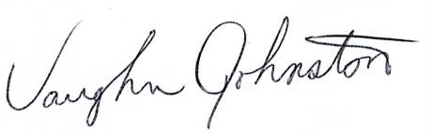Vaughn Johnston Electoral Officer
November 1, 2019

